# **ASSIGNMENT-2**

**(HIVE)**

Employee ID : 232

CSDAIA24AZ003

Step 1: Start the session.

Step 2: Start the HDFS in the virtual machine.

Step 3: Now get the files(movies.item, ratings.data) into local system from external source by using wget command.

Step 4: Now start the hive in the virtual machine.

Step 5: Create a database in the hive.

Step 6: check the database that has been created using show databases command.

Step 7: Now, to create tables in the database we have created, use “use <database_name>” command.

Step 8: Now create the two tables named movieeee and ratingsss in the database we created in hive.

Step 9: Now load the data from files we saved in the local system to the tables we created in the hive.

Step 10: Now write a query to fetch the 5 records having top ratings for movie.

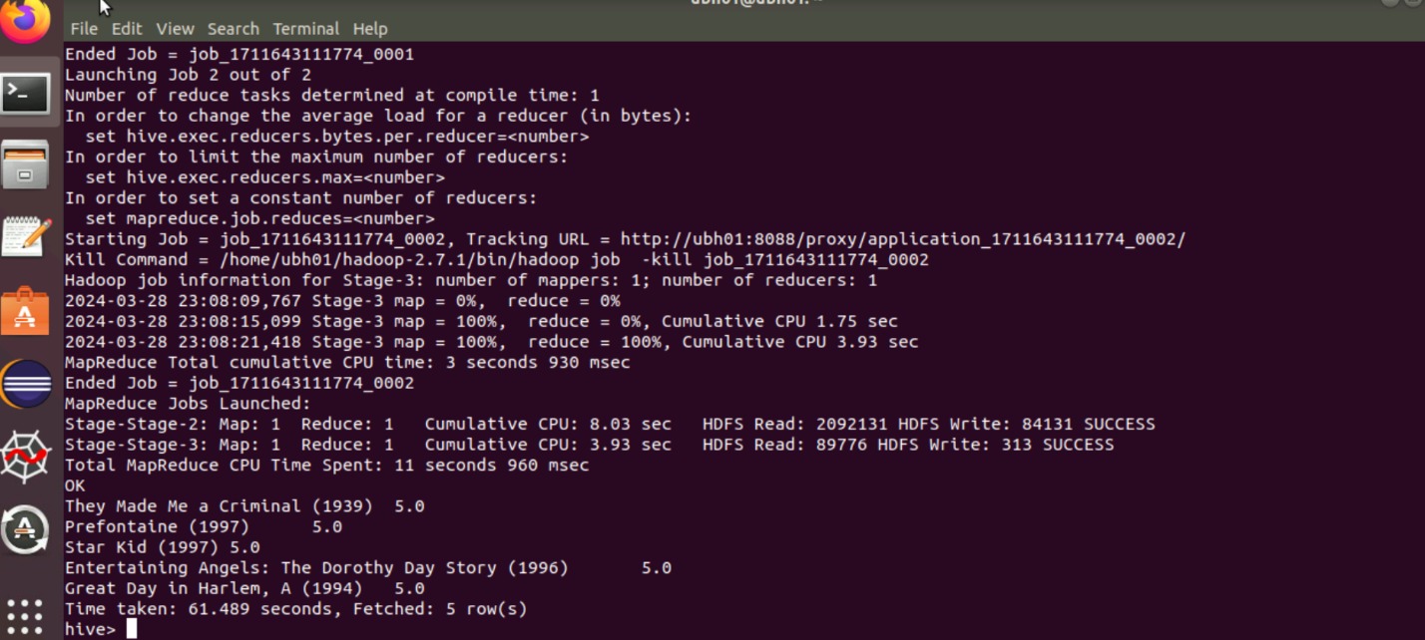

Step 11: Check the records at the output.